**Method to install the C plugin on Vs Code**

1. First make sure Vs Code is installed on the PC.

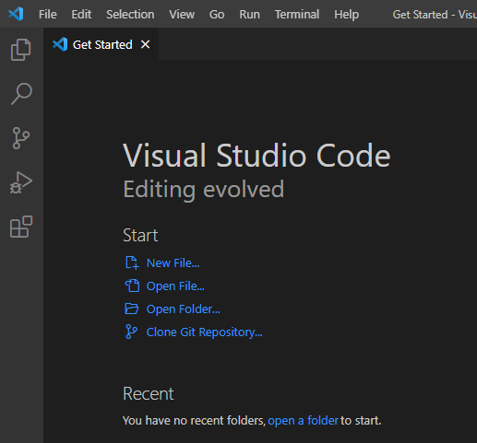

1. You navigate to the extensions tab

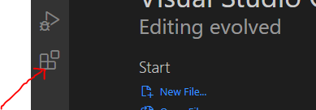

1. Click on the extensions tab and a search bar appears. It will propose you several popular plugins corresponding to different languages. You can search through the popular ones for the C/C++ plugin or you can directly type on the search bar for it.

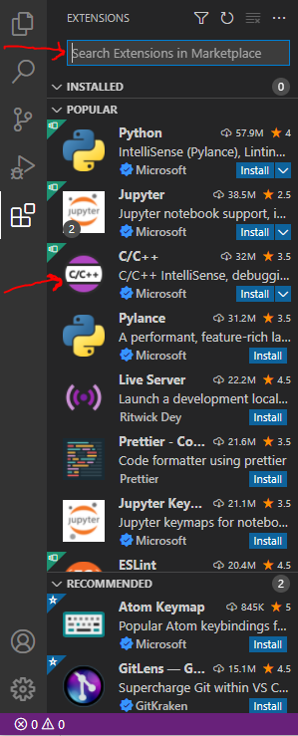

1. You click on install, in order to commence the installation

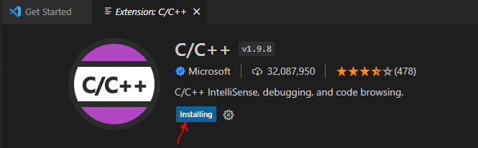

1. When the installation is finished, u get the following.

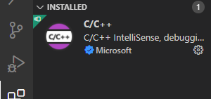

1. After that, you need to install a compiler. The compiler used is the MinGW-w64 Compiler. It can be found here [**https://sourceforge.net/projects/mingw**](https://sourceforge.net/projects/mingw)

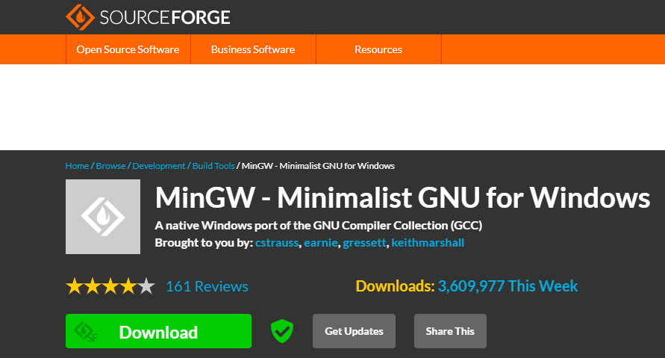

1. You double click on the setup to install it

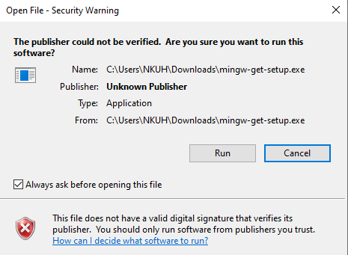

1. Clicking on run, should open another dialogue for downloading the remaining packages

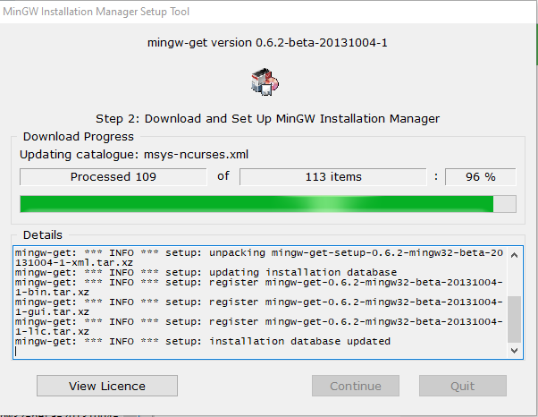

1. Then we choose the compiler packages just for C/C++

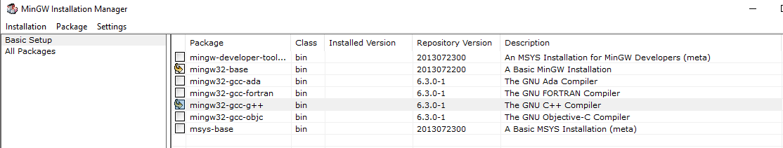

1. After that, we click on the installation found on the top left corner and apply all the changes. When the installation is through, you get the following window

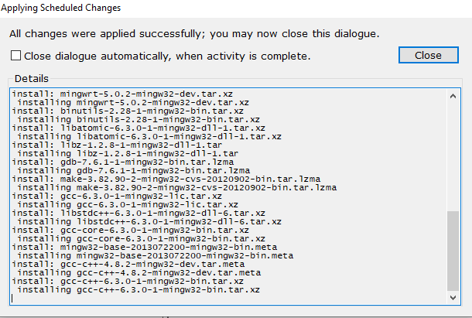

We have installed the compiler, but we need to set the environment path for the MinGW setup

1. We access the bin folder of the MinGW folder and copy the directory path. **C:\MinGW\bin**

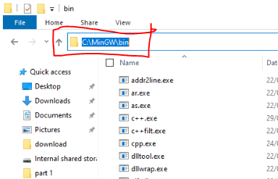

1. You open the control panel and click on advanced system settings. A system properties panel opens, and you click on environment variables and edit path in system variables. Paste the pathway and click on ok

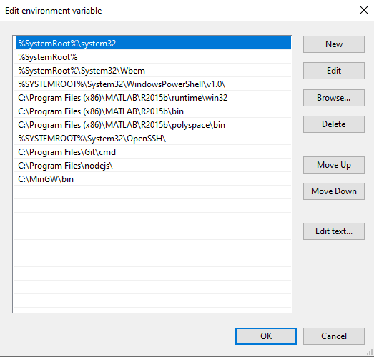

1. Then to verify if it has been installed, you open cmd in administrator mode and type gcc –version. This will show

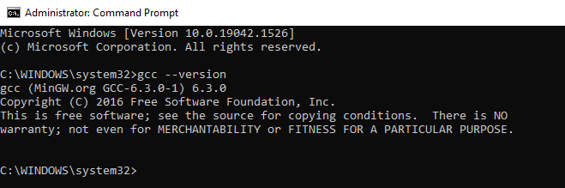

1. We can now verify if it works by executing a little code. The code below is to get the ID of any process being executed

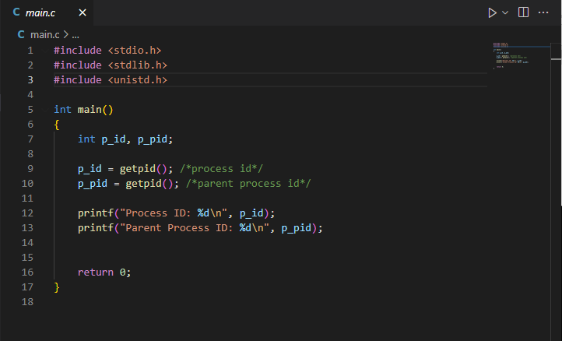

1. The Vs code terminal gives

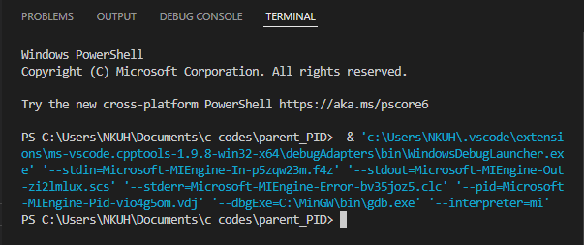

1. And the output of the program is

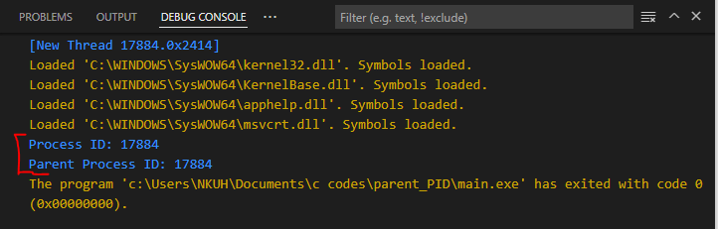

1. But there is a catch in this. Displaying the output on the debug console does so in a read only mode. This hinders us from inputting variables from our keyboard. To correct that, we click on the file button found at the top left corner, then preferences and settings. We choose extensions and scroll down to run code configuration. There we tick, run in terminal and then save with ctrl+s. Then we try a code

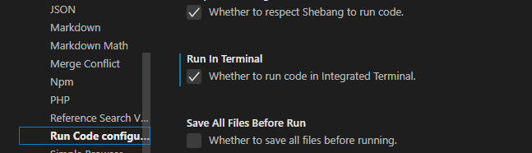

1. As you can see below, the same code launched above now runs in the power shell terminal.

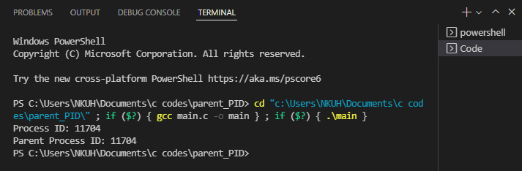

That is how, you install the C-plugin on Vs Code.